Prayer for the young and our families with Kateri

Oh, most humble Kateri

I seek your love and prayers.

I turn to you for your inspiration.

May I know the power of humility; the strength of

seeking God’s will in everything I do this day; the

compassion to care this way for those who are weak and

in need of help; and the faith to forgive those who walk

a hurtful violent path.

Pray with me Kateri that through us, God our Creator

will comfort the orphan, watch over the neglected child,

and wait with the youth who go astray.

You lost your parents and found others along the way to

care for you and guide you. May all

parents and grandparents stay healthy, seek the selfless

love of Jesus, and give where giving is most needed.

May they make wise decisions and heed daily the

Wisdom of the Great Spirit.

Your spirit was strong and your love for Jesus is deep.

May I trust that Christ will turn my weakness

Into His strength and meekness; so that whatever comes

to me this day, I may choose to do God’s will and

faithful will I stay. AMEN

David Shulist S.J.

**KITCHITWA KATERI ANAMEWGAMIK**

**451 Syndicate Ave. N Thunder Bay, ON P7C 3W9**

**Telephone 807 622 5138 email: katerichurch@tbaytel.net**

**Fax 807 626 9632**

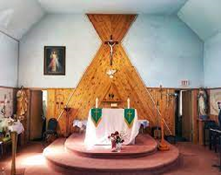

*3rd Sunday of Advent*

*First Reading:*

**Zephaniah 3.14-18**

*Psalm:* **12**

*Second Reading:*

**Philippians 4.4-7**

Gospel:

**Luke 3.10-18**

It’s Gaudete (Rejoice) Sunday, most of today’s readings shimmer and pulsate with joy. It’s the gospel that, at first blush, seems anti-climactic,

As an ascetic John the Baptist preaches sacrifice to those wishing to receive baptism of repentance for the forgiveness of sins. And yet there are three causes of rejoicing here that can also transform our lives.

The first is the stirring of desire for the holy life from such unlikely characters as tax collectors, soldiers and, well, ordinary people. The second is their humble, courageous and fearsome question: “What should we do”? They longed for forgiveness of their sins that wealth, power and position faded away before the promise of a clean heart. And John’s response – his good news- was within their reach: act fairly and honestly. But the greatest cause of rejoicing is the glimpse John gave of a Savior coming to baptize with the Holy Spirit and fire: a baptism of holiness beyond their comprehension and beyond his own grace. As we approach the Advent of our Lord into the very marrow of our humanity, washing away our sins and promising a baptism into his divinity, let us muster the hope and the audacity to ask. “What must I do, to open my heart to this grace today?” Cheryl Ann Smith, Toronto, ON ( Living with Christ)

**Sacraments and Pastoral Needs**

*Baptism:* Please contact the parish office at least one month before the baptism date (622-5138).

*First Communion (Grade Two and older):* Please register with school or with the parish office. Families will be contacted with requirements and other information.

*Confirmation (Grade Eight and older):* Please register with school or with the parish office. Families will be contacted with requirements and other information.

*Marriages:* Please contact the parish office at least **six months** before the wedding date. Preparation will be required for the couple.

*Reconciliation (Penance):* Please make an appointment with one of the priests. (622-5138).

*Sacrament of the Sick (anointing):* please contact the parish office (622-5138) **or in the Regional Hospital, the on-call priest is available in an urgent need.**

*Funerals:* Please contact the parish office to arrange a funeral (622-5138).

**This Week in Our Parish**

**Monday: Dec 16 ,2024**

**12:00 p.m. mass**

**\*\*\*\*\*\*\*\*\*\*\*\*\*\*\*\*\*\*\*\*\*\*\*\*\*\*\*\*\*\***

**AA meeting Sat Dec 21st, 8:00pm**

**\*\*\*\*\*\*\*\*\*\*\*\*\*\*\*\*\*\*\*\*\*\*\*\*\*\*\*\*\*\***

**Sunday: Dec 22 ,2024**

**12:30 pm mass**

**Last Sunday’s Collection: 302.25**

**Last Sunday’s Clothing good will offering $69.80** Thankyou for the ones that attended

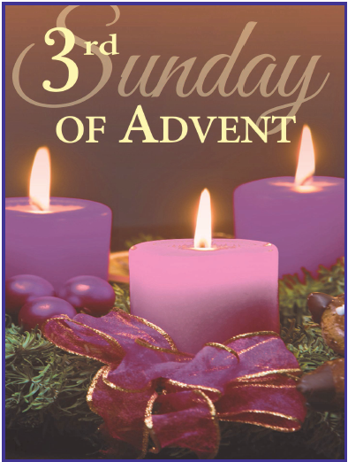

**THE SIGN OF THE CROSS IN OJIBWE LANGUAGE**

**Od ijinikasowining Weossimind,**

**(In the name of the Father,)**

**gaie Wegwissimind,**

**(and of the Son,)**

**gaie Wenijishid-Manito.**

**(and of the Holy Spirit.)**

**Mi ge-ing (Amen)**

ourladyofguadalupecircle.ca

**3**

**---------------------------------------------------**

Mass of Thanksgiving

For the

Society of Jesus in Thunder Bay

On the Occasion of their departure

Sunday, January 5th ,2025

St. Peter’s Church

12:30 pm

***No Mass at Kateri on that Sunday***

______________________________________

Wonderful time at Christmas Decorating night this last Wednesday. Shout out to Pizza Hut on Central Ave for the great deal we were given on the Pizza’s it was much appreciated, thank you, also thank you to all those who came out and helped decorate and donated some decorations.

********************************************

Still time to add a child to the gift list of the parish age 12 and under in book at the back of church. Also tags on the tree to buy a gift for a child. Gifts must be brought in by Dec 22 next Sunday. The office is open 10- 3pm Tues and Thur if you want to bring them to the office.

Administrator**: Grace Esquega**

Deacons: Rev. Mr. Michael Robinson;

Rev. Mr. John Semerling

Rev Mr. Dave Frank

Ministers of Service: Sharon Arsenault; Susan Eberhardt; Grace Esquega;

Penny Fitzpatrick; Sandra Reynolds; Tammy Robinson; Lisa Semerling ; Debbie Esquega

Secretary/Bookkeeper: Sharon Arsenault

Parish Priest**: Rev. Gerry McDougall, SJ**

Parish Office Hours Tuesday & Thursday: 10:00 AM – 3:00 PM

**Masses for the Lord’s Day Weekday Mass Schedule**

**Sunday: 12:30 PM.**  **Monday: 12:00 PM**.

DIVINE MERCY DEVOTIONS Please contact the parish office.

THE HOLY ROSARY is recited half hour before all Weekday Masses