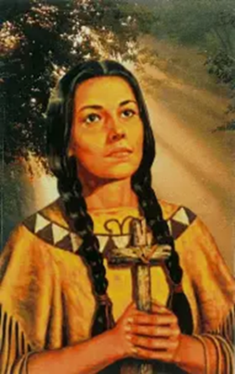 ***Kateri Prayer Days***

***Sept 26,27,28,2025***

***“ Jesus is Lord ”***

***Starting Friday Sept 26, at 7:00 pm Kateri Church***

* ***Dr. Michael Rozeluk – Guest Speaker***
* ***Healing Service – Lead by Michael Rozeluk***
* ***Sharing and witnessing***
* ***Sunday mass 12:30 pm***

***Celebrated by Bishop Campeau***

* ***Everyone is Welcome***

***451 Syndicate Ave, Thunder Bay***

***Call office 807 622 5138***

***Office hrs Tuesday and Thursday***

***Email: katerchurch@tbaytel.net***