Prayer for the young and our families with Kateri

Oh, most humble Kateri
I seek your love and prayers.
I turn to you for your inspiration.

May I know the power of humility; the strength of
seeking God’s will in everything I do this day; the
compassion to care this way for those who are weak and
in need of help; and the faith to forgive those who walk
a hurtful violent path.

Pray with me Kateri that through us, God our Creator
will comfort the orphan, watch over the neglected child,
and wait with the youth who go astray.

You lost your parents and found others along the way to
care for you and guide you. May all
parents and grandparents stay healthy, seek the selfless
love of Jesus, and give where giving is most needed.
May they make wise decisions and heed daily the
Wisdom of the Great Spirit.

Your spirit was strong and your love for Jesus is deep.
May I trust that Christ will turn my weakness
Into His strength and meekness; so that whatever comes
to me this day, I may choose to do God’s will and
faithful will I stay. AMEN
David Shulist S.J.

KITCHITWA KATERI ANAMEWGAMIK
451 Syndicate Ave. N Thunder Bay, ON P7C 3W9
Telephone 807 622 5138 email: katerichurch@tbaytel.net
Fax 807 626 9632
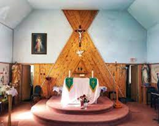

33rd Sunday in Ordinary Time
What a powerful message of encouragement and hope we are given in today’s readings, especially during these challenging times filled with distractions.
It’s comforting to be reminded that the lord is the judge. He protects and uses us to lead souls to him when we are aligned with his will. Like taking our vehicle to the mechanic, even just a routine oil change, it’s good to do an examination of conscience on a regular basis, ideally every day. Maybe we’ve lost track of our spiritual odometer, but it’s never to late to get back on track. Doing this is good for our soul and will keep us going in the right direction, without deviating from God’s will.
The end of the liturgical year is a busy time when we might lose sight of our priorities. Instead, we can take time to reflect on where we can improve spiritually and set goals for the upcoming year. This is not easy because the distractions of the world are constant and increasingly noisier. They aren’t necessarily bad and may be things that need to get done; but when we let them take over, our spiritual priorities suffer. On this World Day of the Poor; let us make the poor a priority in our lives and strive to love Our Lord in all whom we meet. Shara Escobar, Ottawa, ON (living with Christ)

Sacraments and Pastoral Needs
Baptism: Please contact the parish office at least one month before the baptism date (622-5138).
First Communion (Grade Two and older): Please register with school or with the parish office. Families will be contacted with requirements and other information.
Confirmation (Grade Eight and older): Please register with school or with the parish office. Families will be contacted with requirements and other information.
Marriages: Please contact the parish office at least six months before the wedding date. Preparation will be required for the couple.
Reconciliation (Penance): Please make an appointment with one of the priests. (622-5138).
Sacrament of the Sick (anointing): please contact the parish office (622-5138) or in the Regional Hospital, the on-call priest is available in an urgent need.
Funerals: Please contact the parish office to arrange a funeral (622-5138).

This Week in Our Parish 2025
Monday Mass Nov 17,2025
12:00pm
Next Sunday
Sunday: Nov 23th,2025
Mass 12:30 pm
Last Sunday’s Collection: $415.75

THE SIGN OF THE CROSS IN OJIBWE LANGUAGE
Od ijinikasowining Weossimind,
(In the name of the Father,)
gaie Wegwissimind,
(and of the Son,)
gaie Wenijishid-Manito.
(and of the Holy Spirit.)
Mi ge-ing (Amen)
ourladyofguadalupecircle.ca

3
---------------------------------------------------

St, Anne’s Two-Bit Auction
Fundraiser Lots of Prizes
Come and enjoy the day
Saturday Nov 22, 12pm - 4pm
Please call Eleanor at 807623 7382 or 807 623 8301 to drop off donations. Tickets at door which include Chile and Bannock.
A wonderful Birth
Death is the ultimate grace
And the culmination of our Christian life. It is not the end, as too many think,
But the beginning of a wonderful birth.
It marks not the end of a creature, but their true development, their full realization of love.
It fulfills our belonging in God’s life,
Removing barriers that, here on Earth,
Prevent us from enjoying life in God completely.
Death shows us to attend freely
To Love Eternal,
To be aware that Love gives itself to us
And to live in God forever….
When I think about my approaching death,
I say to myself,
“Good- soon I will see God!”
Venerable Marthe Robin

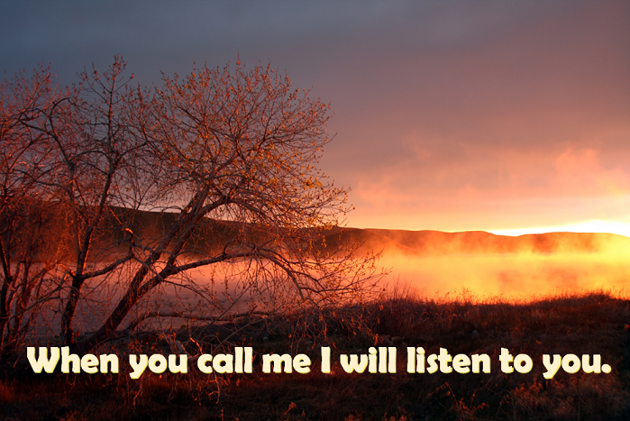

Administrator: Grace Esquega
Deacons: Rev. Mr. Michael Robinson;
Rev. Mr. John Semerling
Rev Mr. Dave Frank
Ministers of Service: Sharon Arsenault; Susan Eberhardt; Grace Esquega;
Penny Fitzpatrick; Sandra Reynolds; Tammy Robinson; Lisa Semerling ; Debbie Esquega
Secretary/Bookkeeper: Sharon Arsenault
Parish Priest: Rev. Biju mathew
Parish Office Hours Tuesday & Thursday: 10:00 AM – 3:00 PM
Masses for the Lord’s Day Weekday Mass Schedule
Sunday: 12:30 PM. Monday: 12:00 PM.

DIVINE MERCY DEVOTIONS Please contact the parish office.
THE HOLY ROSARY is recited half hour before all Weekday Masses

