Prayer for the young and our families with Kateri

Oh, most humble Kateri
I seek your love and prayers.
I turn to you for your inspiration.

May I know the power of humility; the strength of
seeking God’s will in everything I do this day; the
compassion to care this way for those who are weak and
in need of help; and the faith to forgive those who walk
a hurtful violent path.

Pray with me Kateri that through us, God our Creator
will comfort the orphan, watch over the neglected child,
and wait with the youth who go astray.

You lost your parents and found others along the way to
care for you and guide you. May all
parents and grandparents stay healthy, seek the selfless
love of Jesus, and give where giving is most needed.
May they make wise decisions and heed daily the
Wisdom of the Great Spirit.

Your spirit was strong and your love for Jesus is deep.
May I trust that Christ will turn my weakness
Into His strength and meekness; so that whatever comes
to me this day, I may choose to do God’s will and
faithful will I stay. AMEN
David Shulist S.J.

KITCHITWA KATERI ANAMEWGAMIK
451 Syndicate Ave. N Thunder Bay, ON P7C 3W9
Telephone 807 622 5138 email: katerichurch@tbaytel.net
Fax 807 626 9632
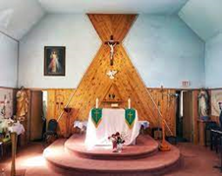

Epiphany of the Lord
Dear brothers and sisters in Christ,
Today we celebrate the Solemnity of the Epiphany of the Lord. The word Epiphany means manifestation or revelation. On this feast, the Church proclaims that Jesus is revealed not only to Israel, but to the whole world. This is beautifully shown in the visit of the Magi—wise men from the East—who came searching for the newborn King. Though they were not Jews, their hearts were open to God’s light. As the prophet Isaiah says, “Nations shall walk by your light, and kings by your shining radiance” (Isaiah 60:3).
The Magi were sincere seekers. They left their comfort, faced difficulties, and followed the star. St John Chrysostom reminds us that they came from far away to honor Christ, while many chosen to Him failed to recognize Him. Their journey teaches us that God reveals Himself to those who truly seek Him.
The gifts they offered were full of meaning: gold for Christ the King, frankincense for Christ our God, and myrrh pointing to His suffering and death. As St Gregory the Great explains, even in the crib, Jesus is revealed as King, Lord, and Savior.
Sadly, even today, many modern “Herod’s” feel threatened by Christ. Faith is often pushed aside, mocked in media, or treated as outdated. As reverence fades, churches are closed or sold—not because Christ has failed, but because faith has grown cold. Dear friends, Epiphany calls us to be like the Magi: to seek Christ sincerely, worship Him humbly, and offer Him our best. Let us not be ashamed of our faith but boldly proclaim Jesus as our Lord and Savior. 🌟 Fr. Bihu Mathew
Sacraments and Pastoral Needs
Baptism: Please contact the parish office at least one month before the baptism date (622-5138).
First Communion (Grade Two and older): Please register with school or with the parish office. Families will be contacted with requirements and other information.
Confirmation (Grade Eight and older): Please register with school or with the parish office. Families will be contacted with requirements and other information.
Marriages: Please contact the parish office at least six months before the wedding date. Preparation will be required for the couple.
Reconciliation (Penance): Please make an appointment with one of the priests. (622-5138).
Sacrament of the Sick (anointing): please contact the parish office (622-5138) or in the Regional Hospital, the on-call priest is available in an urgent need.
Funerals: Please contact the parish office to arrange a funeral (622-5138).

This Week in Our Parish 2025
Monday Mass Jan 6,2026 12:10p.m.
Sunday: Jan 11th ,2026.
Last Sunday’s Collection:
Christmas $652.20
Sunday 28/25 $349.60

THE SIGN OF THE CROSS IN OJIBWE LANGUAGE
Od ijinikasowining Weossimind,
(In the name of the Father,)
gaie Wegwissimind,
(and of the Son,)
gaie Wenijishid-Manito.
(and of the Holy Spirit.)
Mi ge-ing (Amen)
ourladyofguadalupecircle.ca

3
---------------------------------------------------

Happy New Year

Walk into the new year trusting God completely.

Epiphany of the Lord
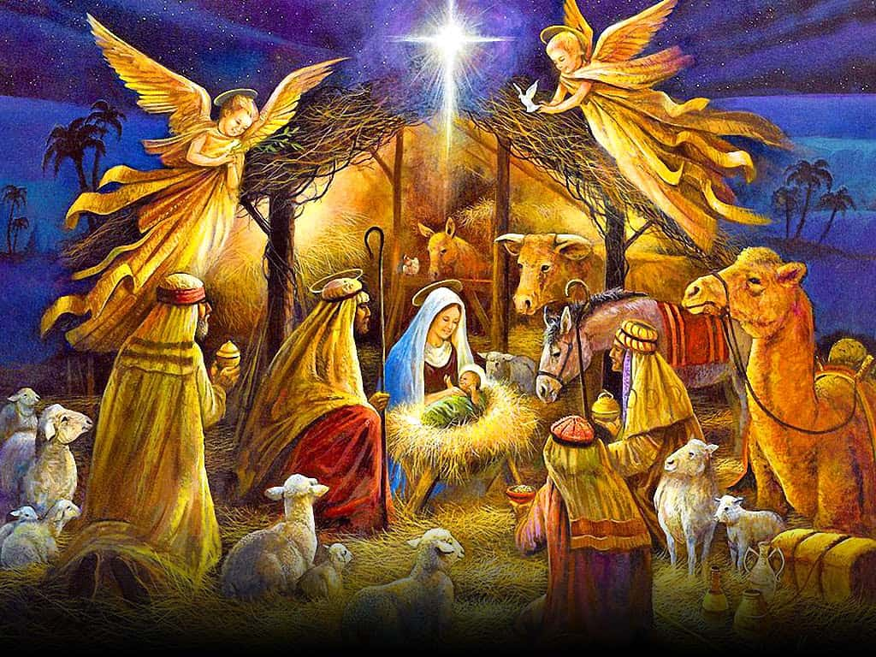
Administrator: Grace Esquega
Deacons: Rev. Mr. Michael Robinson;
Rev. Mr. John Semerling
Rev Mr. Dave Frank
Ministers of Service: Sharon Arsenault; Susan Eberhardt; Grace Esquega;
Penny Fitzpatrick; Sandra Reynolds; Tammy Robinson; Lisa Semerling ; Debbie Esquega
Secretary/Bookkeeper: Sharon Arsenault
Parish Priest: Rev. Biju mathew
Parish Office Hours Tuesday & Thursday: 10:00 AM – 3:00 PM
Masses for the Lord’s Day Weekday Mass Schedule
Sunday: 12:30 PM. Monday: 12:00 PM.

DIVINE MERCY DEVOTIONS Please contact the parish office.
THE HOLY ROSARY is recited half hour before all Weekday Masses

