Prayer for the young and our families with Kateri

Oh, most humble Kateri
I seek your love and prayers.
I turn to you for your inspiration.

May I know the power of humility; the strength of
seeking God’s will in everything I do this day; the
compassion to care this way for those who are weak and
in need of help; and the faith to forgive those who walk
a hurtful violent path.

Pray with me Kateri that through us, God our Creator
will comfort the orphan, watch over the neglected child,
and wait with the youth who go astray.

You lost your parents and found others along the way to
care for you and guide you. May all
parents and grandparents stay healthy, seek the selfless
love of Jesus, and give where giving is most needed.
May they make wise decisions and heed daily the
Wisdom of the Great Spiri

Your spirit was strong and your love for Jesus is deep.
May I trust that Christ will turn my weakness
Into His strength and meekness; so that whatever comes
to me this day, I may choose to do God’s will and
faithful will I stay. AMEN
David Shulist SJ,Jesus,shows himself to the disciples for the first time
KITCHITWA KATERI ANAMEWGAMIK
451 Syndicate Ave. N Thunder Bay, ON P7C 3W9
Telephone 807 622 5138 email: katerichurch@tbaytel.net
Fax 807 626 9632
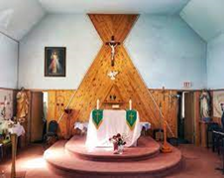

From the Pastor's Desk. Pentecost Sunday
Dear Friends in Jesus Christ, today is the Feast of Pentecost. The word Pentecost comes from the Greek word pentēkostē, which literally means "fiftieth." It is the 50th day after Easter Sunday. Pentecost is also called as the "Birthday of the Church."
We see in the Gospel of John (20:19-23) that the disciples were locked in the upper room, hiding in total fear. Completely crushed by past failures and uncertain of their future, they were interrupted when Jesus suddenly appeared right through those locked doors. He greeted them saying, “Shalom aleichem”—"Peace be with you." Jesus then commissioned them, saying, "As the Father has sent me, so I send you." When he had said this, he breathed on them and said, "Receive the Holy Spirit."
Why is the Holy Spirit so necessary? Without the Spirit, our lives become miserable. We wander off track, fall into deep sadness, lose our sensitivity to sin, and feel completely empty.
King David knew the danger of losing the Holy Spirit very well. After committing the terrible sins of adultery and murder, he realized he had fetched the wrath of God. He was terrified that God might take the Holy Spirit away from him, just as God did to Saul.
When Saul first became king, he was humble and deeply connected to God. But as the pressures of the throne grew, he got too busy expanding his kingdom. He had no time for God and relied entirely on his own strength. That spiritual drift cost him everything. Once the Spirit left Saul, a "distressing" or "tormenting" spirit took over. Saul spent the rest of his life gripped by intense paranoia, explosive anger, and deep depression (1 Samuel 16:14).
Continued…
Pastor’s Desk continued David watched this heartbreaking collapse of Saul firsthand. He wasn't just worried about losing his crown; he was terrified that Saul’s tragic fate would happen to him too. That’s why David practically begs God, we read in Psalm 51:11, “Please, don’t take your Holy Spirit away from me!” He knew the value of Holy Spirit and what happens if he loses the holy Spirit.
When we lose that active connection with the Holy Spirit, a dark, wicked spirit of fear and anxiety moves right into that empty space—just like what happened to King Saul. Our hearts hardens and our consciences go numb. Saint Paul warns us about this danger in Ephesians 4:19, "They have lost all sensitivity and have abandoned themselves to licen-tiousness, greedy to practice every kind of impurity."
That is why Pentecost is such great news! Jesus gives us His peace to heal our past, and the Holy Spirit to guide our future. He gives us the peace, strength, and confidence to face whatever comes on our way, just as He gave to His disciples who were hiding in fear and uncertainty in life.
So, dear friends, let’s keep the Holy Spirit active in our hearts every day and enjoy the peace that Jesus gives us! May the good Lord bless you and your families, protecting you from all possible dangers. Amen.
Administrator: Grace Esquega
Deacons: Rev. Mr. Michael Robinson;
Rev. Mr. John Semerling
Rev Mr. Dave Frank
Ministers of Service: Sharon Arsenault; Susan Eberhardt; Grace Esquega;
Penny Fitzpatrick; Sandra Reynolds; Tammy Robinson; Lisa Semerling ; Debbie Esquega
Secretary/Bookkeeper: Sharon Arsenault
Parish Priest: Rev. Biju mathew
Parish Office Hours Tuesday & Thursday: 10:00 AM – 3:00 PM
Masses for the Lord’s Day Weekday Mass Schedule
Sunday: 12:30 PM. Monday: 12:10 PM Please contact the parish office. Tues and Thursday 10:00Am to 3:00 pm if needed
807 622 5138
T
This Week in Our Parish 2026
Monday May 25,2026
Mass at 12:10 p.m.
11:30 to 12:00 pm Holy Adoration
Next Sunday May 31,2026 12:30 pm
Last week’s Collection: $ 50065
Candles: $33.00



HE SIGN OF THE CROSS IN OJIBWE LANGUAGE
Od ijinikasowining Weossimind,
(In the name of the Father,)
gaie Wegwissimind,
(and of the Son,)
gaie Wenijishid-Manito.
(and of the Holy Spirit.)
Mi ge-ing (Amen)

-

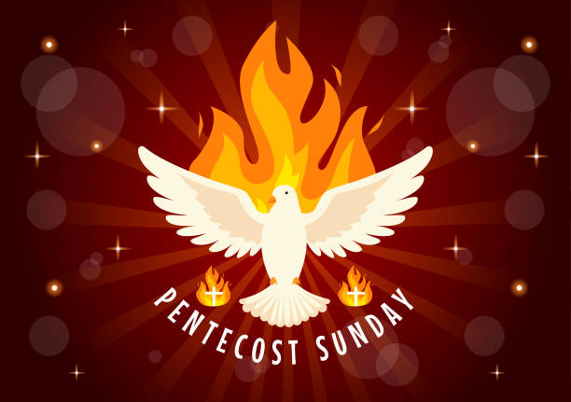

DIOCESAN NEWSLETTER - Throughout the year we will be accepting articles for the Diocesan Newsletter, if you have anything you would like to submit for it, please send it to Grace at dotb.communications@gmail.comn.

Making Medicine Bundles
Where: Kateri Church
For: Youth 13-18 and Elders
When: Thursday, May 28,2026
Time: 4:30 pm to 6:00 pm

